# Project Spyn:Brainstorming

Present:Tongye Wu,Dhruval Jayprakash Anandkar,Even Mehreteab,Hossain Ahmed

**Description:**

* Tongye:

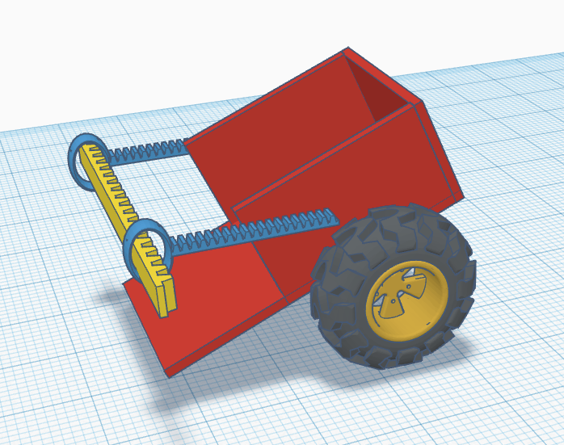

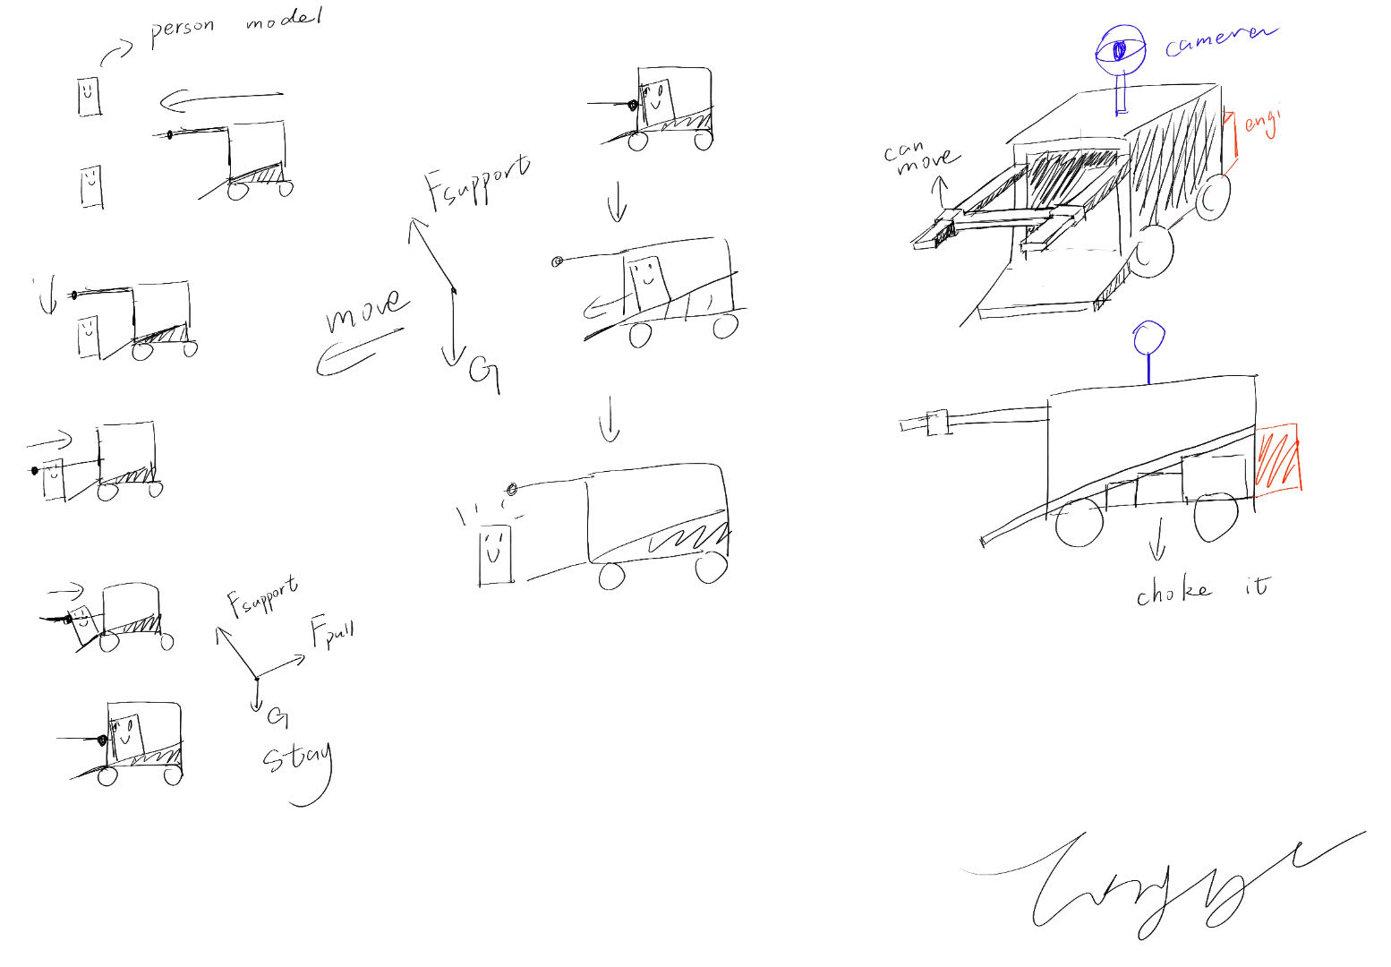

* Here is Tongye’s design. This car is composed of wheels(black), a body(red), a telescopic rod（light blue and yellow).
* This car can let people get into the car through a telescopic rod, which is able to move up and down and contract inward. The rod will block while the car is moving to prevent people from dropping from the car.
* Dhruval Jayprakash Anandkar:

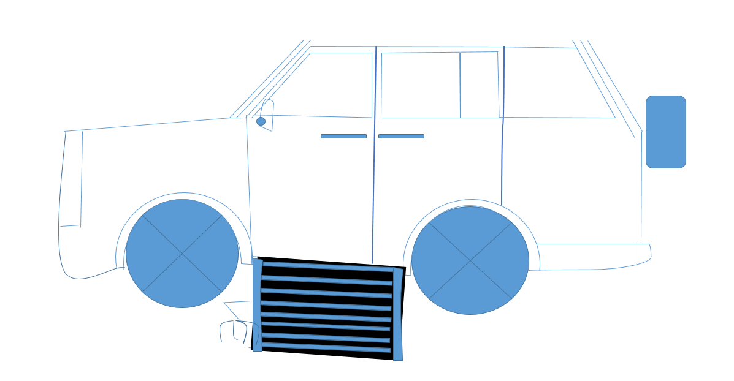

* Robotic Arm Design: The car has a robotic arm inside that extends out to pick up the wheelchair. It has joints and a gripper to lift the wheelchair safely.
* Wheelchair Detection: The robotic arm has sensors to find and approach the wheelchair.
* Pickup and Placement: Once the wheelchair is found, the arm grabs it and moves it to the car's storage area.
* Loading into the Car: The arm carefully places the wheelchair inside the car, making sure it's secure and doesn't block other passengers.
* Control System: The arm is controlled by a system that can be operated by the user or automatically. It ensures the arm moves safely and avoids obstacles.
* Even Mehreteab: 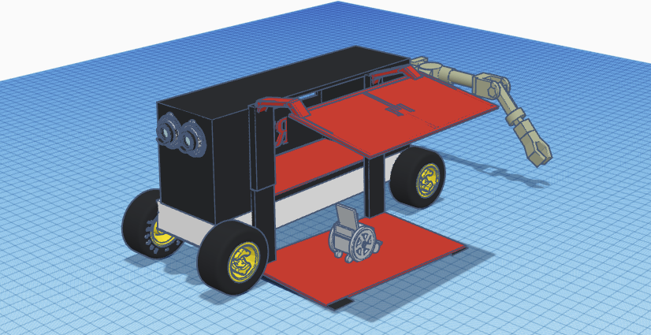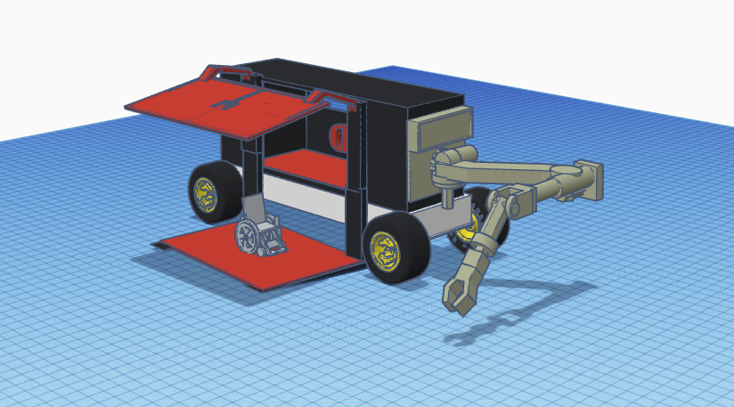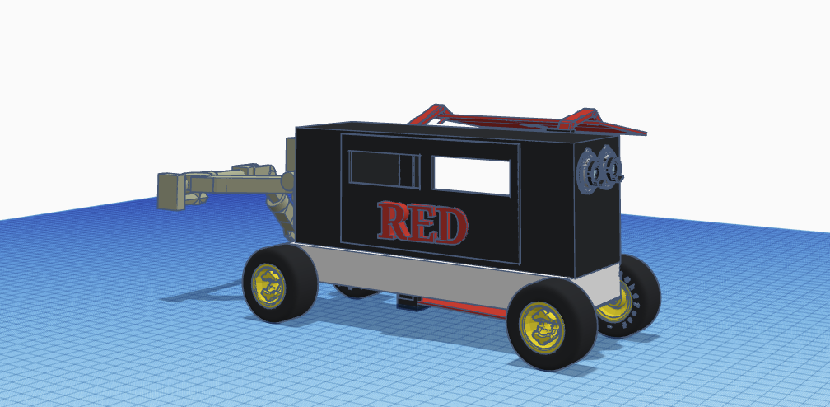

This vehicle is an autonomous vehicle that has a very convenient and simple design like a “forklift” that lifts a wheelchair safely into the vehicle. The door is lifted during the process, and it can be used as a shade to the person in the wheelchair and it stays out the way so that the “forklift” can retract in. on the back there is an arm that can place the wheelchair on the “forklift”. The front are cameras for the autonomous. The “forklift” surface has a magnetic force to it so it keeps the wheelchair stabilized as it is put in the vehicle. The door is the first thing that engages so that the “forklift” can engage and lower unto the ground, after the arm engages and pulls the wheelchair unto the “forklift”, this is all calculated by the vehicle as it has many small cameras that can detect a person/wheelchair and it is slow and study. After the wheelchair has been lifted into the vehicle, the door disengages and closes, and the arm positions itself so that the car isn’t pulled backward due to the size of the arm. In the vehicle there will be seatbelts, hooks that will keep the wheelchair in one place, the car’s speed will be average. The suspension of the car will be suited to help the vehicle be stable. There are emergency caller buttons in the vehicle in case the person needs it, the car also has a health monitor so it calls emergency services if the person is experiencing a medical emergency.

* Hossain Ahmed:

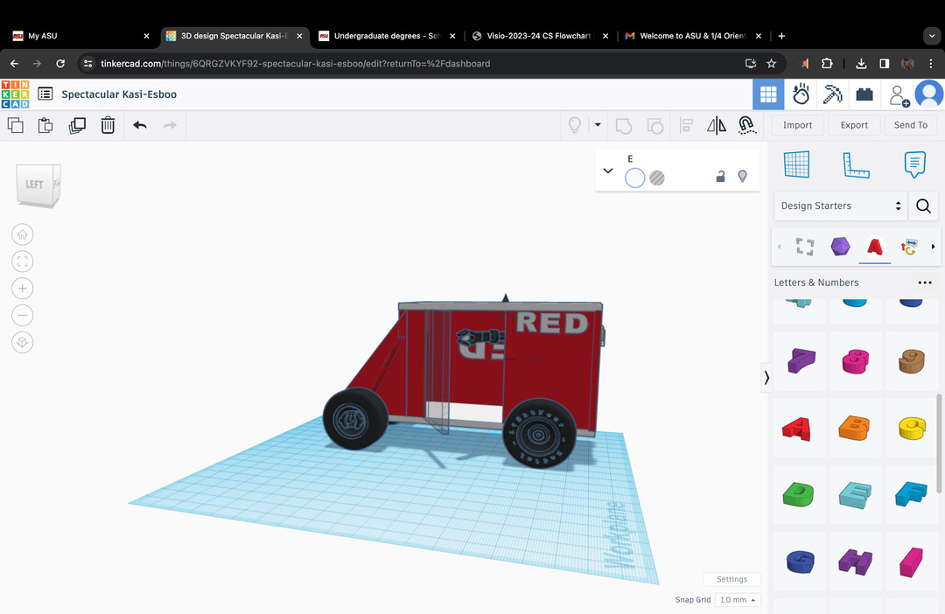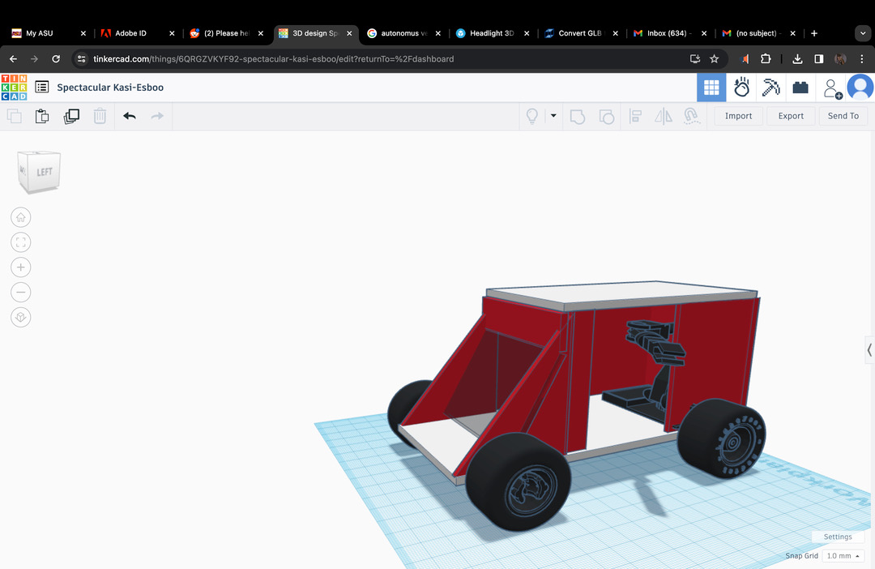

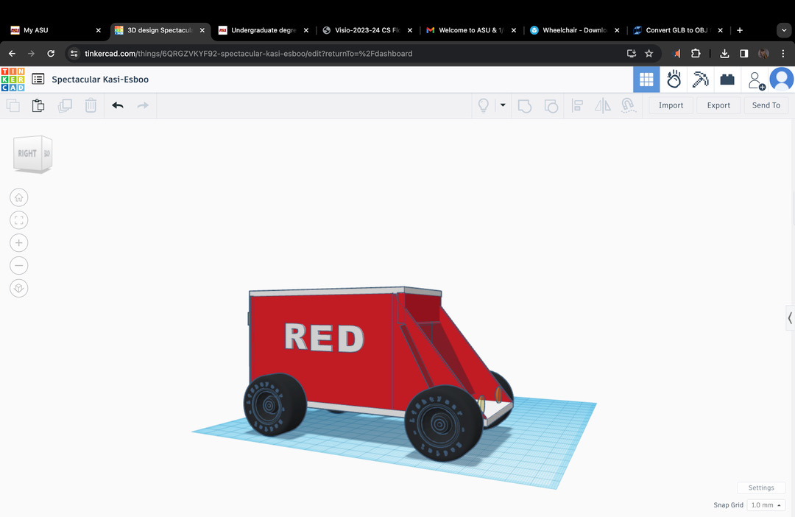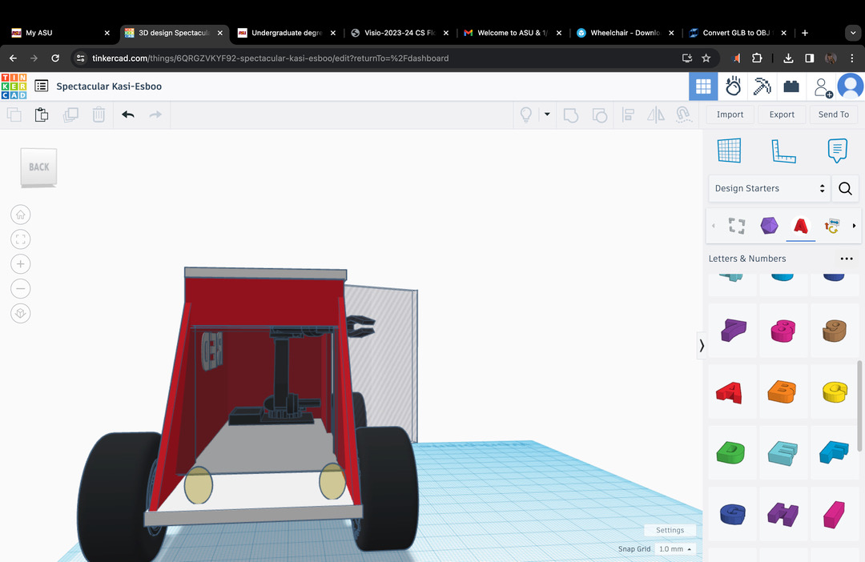

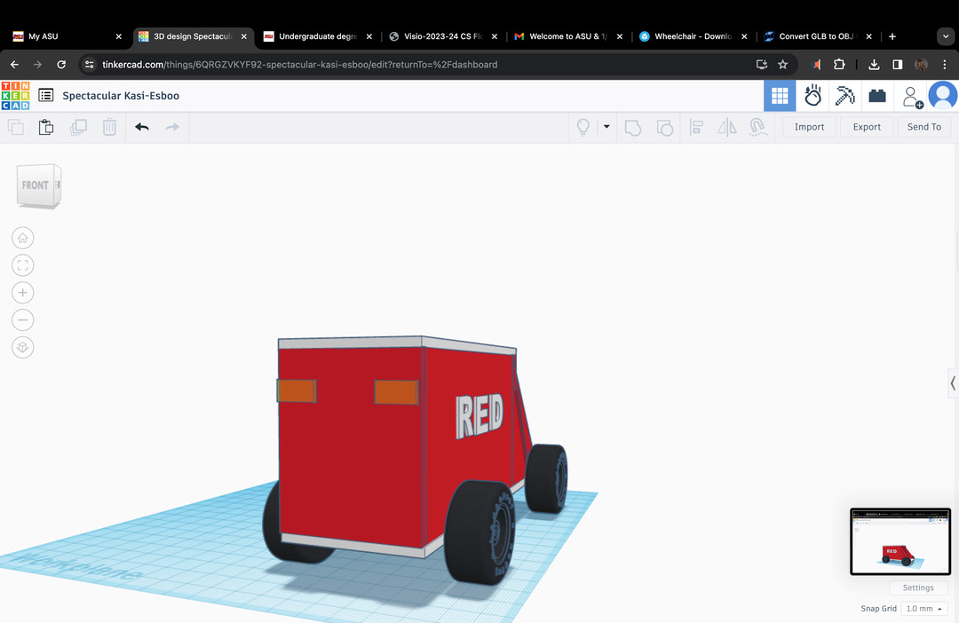

As you can see the design is very human and friendly. To reduce cost I have focused more on the hardware than design. My vehicle is of course automatic and will have no person to carry which will maximize privacy and safety. My windshield and glasses are tinted and there are adequate cameras and sensors all around the vehicle. For safety there will be a 911 emergency button. There will be seatbelts and robotic arms to hold the wheelchair securely.Moreover, I'm using very good suspension to minimize the wiggle inside the car.

**Decision table:**

|  |  |  |  |  |  |
| --- | --- | --- | --- | --- | --- |
| **Criteria** | **weighting** | **Idea 1**  **(Tongye)** | **Idea 2**  **(Dhruval)** | **Idea 3**  **(Hossain)** | **Idea 4**  **(Even)** |
| **speed** | **10** | **3*10=30** | **6*10 = 60** | **6*10 =60** | **6*10=60** |
| **power** | **5** | **5*5 = 25** | **4*5=20** | **6*5 = 30** | **7*5=35** |
| **size** | **3** | **1*3=3** | **6*3 = 18** | **5*3 = 15** | **9*3=27** |
| **cost** | **3** | **5*3=24** | **3*3=9** | **4*3 = 12** | **8*3=24** |
| **sum** |  | **112** | **107** | **117** | **146** |

**Here, the Highest total has been highlighted in Yellow.**

**minimally viable prototype of the best design:** Idea 4 (Even) which is 146. Evan's model is 6 in terms of speed, 7 in power, 9 in size, and 8 in cost which makes it the best choice for using it as a prototype from our group.



Snapshot of the Prototype

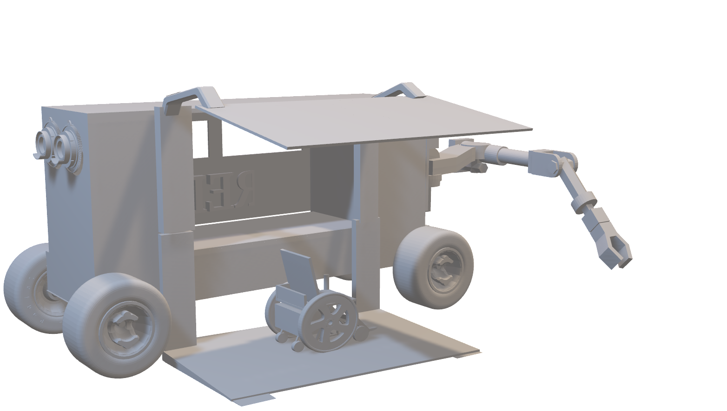

3D model of the prototype

**Diagram to model the behavior of the prototype:**

Pick-up process:

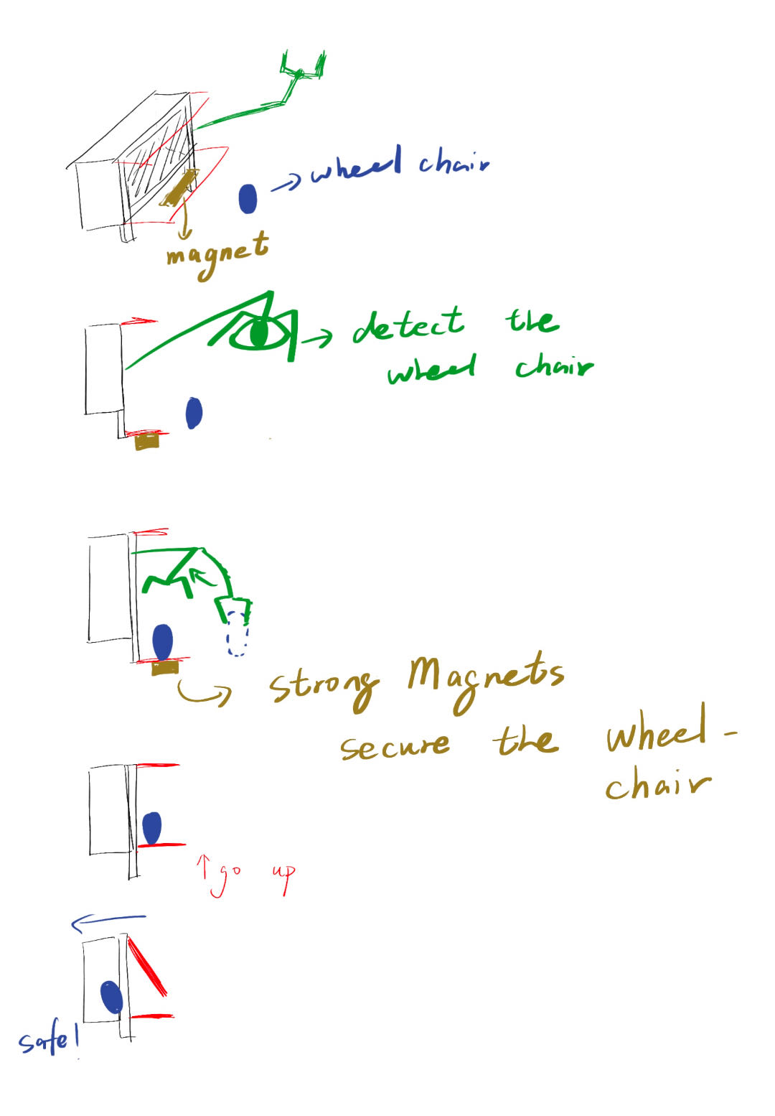

1. There will be detector for wheelchair.
2. The arm will pick it up.
3. And place it to the forklift base.
4. Magnets are used to stabilize the wheelchair.
5. The forklift retracts and secures the wheelchair to the wall though safety belts.
6. Strong Magnets in the base of forklift secure the wheelchair.

Drop-in process:

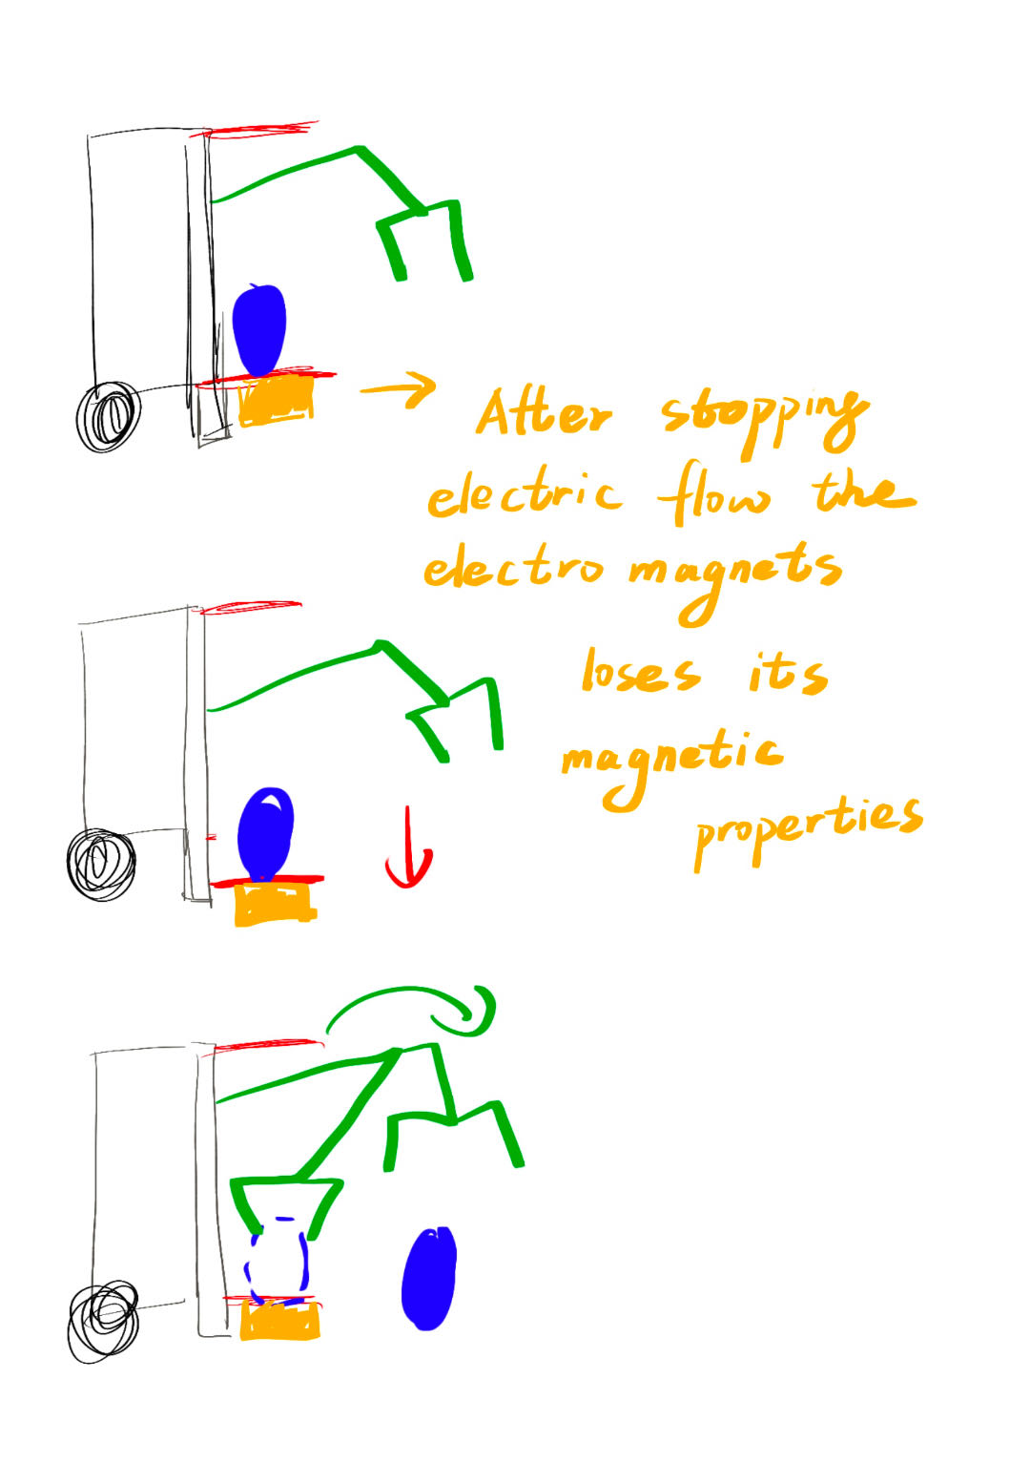

1. After stopping electric flow, the electromagnets lose its magnetic properties.
2. The Robotic arm will again pick the wheelchair up and drop it safely in the drop-in location.